|  |
| --- |
| **Lachrimae: The Seaven Teares** |
| Rated E10+  Number of Players: 1  Platform: Switch, PC |

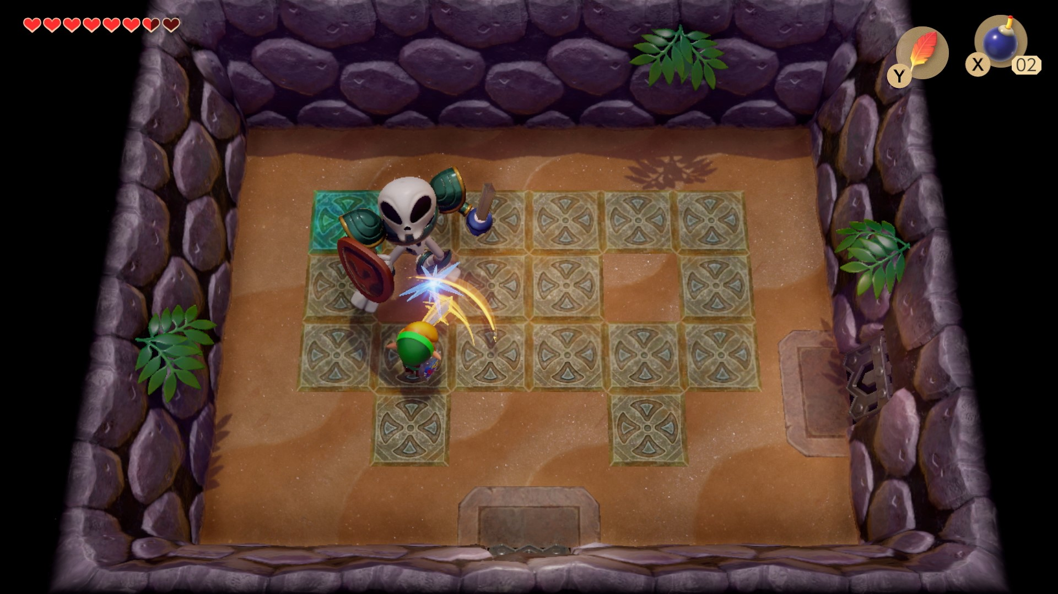

* Take on the role of Ajax in a quest to make your escape by solving puzzles to find the seven lost keys to the getaway portal on a skeleton infested island. Fend for yourself with your sword and bow, and other abilities you earn on your journey.
* Enjoy interactive puzzles and challenges in a top-down perspective adventure!
* 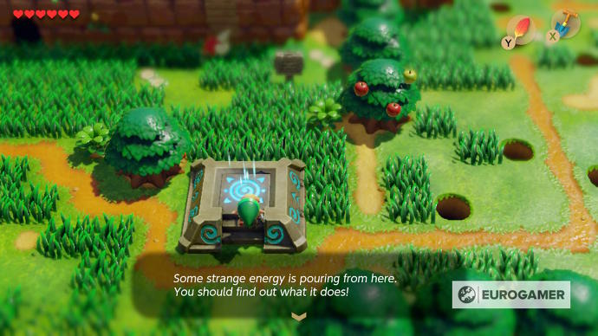Enjoy exploring the colorful and stylized design in this escape adventure! Imagine a Zelda/Jumanji style game! This is it.